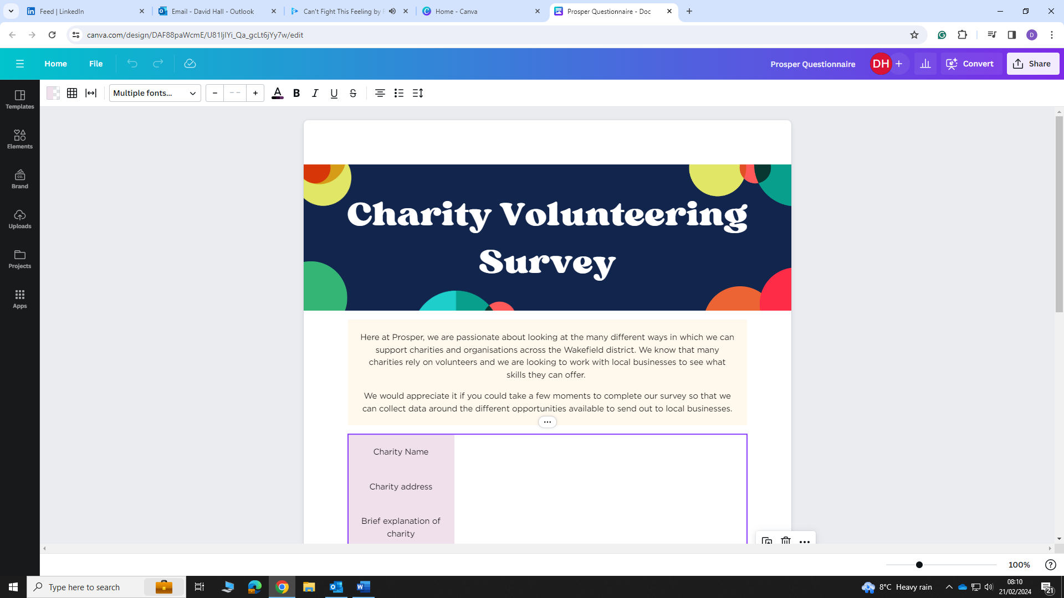

Here at Prosper, we are passionate about looking at the many different ways in which we can support charities and organisations across the Wakefield district. We know that many charities rely on volunteers and we are looking to work with local businesses to see what skills they can offer.

We would appreciate it if you could take a few moments to complete our survey so that we can collect data around the different opportunities available to send out to local businesses.

|  |  |
| --- | --- |
| Charity Name and address |  |
| Geographical Area |  |
| Brief Explanation of Charity |  |
| Main Contact |  |
| Position |  |
| Email Address |  |
| Telephone Number |  |
| Do you currently run a volunteering programme? |  |
| Do you have a volunteering policy? (if not, Nova can support with this)  Do you have a safeguarding policy? (if not, Nova can support with this) |  |
| Do you currently require more volunteers in your charity? |  |



Please list the roles needed for volunteers with a brief explanation of the role. This could be anything from helping at events, fundraising, 1-1 mentoring, coaching charity staff, advice sessions for beneficiaries of your charity, supporting with service delivery, social media and digital support, graphic design…. and so much more! Some other examples are:

- HR (human resources)

- Legal

- Accountancy and Finance

- Marketing and Communications

- Website design

**Please note that all of the volunteering hours given will need to be logged and reported back to Prosper.**

Volunteering Support Required:

Commencement Date:

Commitment (one off/weekly/monthly):

Hours Required:

DBS Required? **YES / NO**

Please email back to Julie Booth at julie@prosperwakefielddistrict.org

Prosper Wakefield District will use the information you provide on this form to contact you and to give information to the businesses who are interested in volunteering for your organisation. We will also share the information provided with Nova.

**Please get in touch at julie@prosperwakefielddistrict.org if you wish to unsubscribe at any time.**